Priming for Efficient Patient Encounters
Just like priming a pump, taking 1 minute to “PRIME” your learners prior to each patient encounter will improve efficiency and effectiveness of your teaching and patient encounters!
Priming involves 3 P’s:
PREPARE with your learner at start of session; PRIME before each patient interaction; PLAN next steps.

1
PREPARE with your learner from “Well” of Patient Encounters

Scan Clinic Schedule: Look for urgent/must be addressed patient issues; schedule length; learner friendly patients

Check Learner Needs/Gaps: Rotation/training requirements – learner’s gaps = today’s focus (e.g., chronic disease; prevention; communication)

Rescan Schedule: Match patients with learner needs and clinic flow
PREPARE 3-5 min

3

1
min

1
2 min

1
min

1
min

1
min

1
2

High Quality, Efficient Patient Care & Learning
PRIME for EACH patient by telling the learner in < 1 minute:

Who is the Patient: 56 y/o patient; Type 2 DM; Here for 3 month follow up; DM is uncontrolled

What to Do & Time: Assess barriers to control DM; Consider Motivational Interviewing; 10 minutes

Why Do it: Chronic Disease management requires patient commitment & engagement

What You Expect: 2 minute summary of top 2 actionable barriers patient agrees to work on
PRIME 1 min

3
PLAN what you and/or learner will do when go back in to see patient following the learner’s 2-minute summary:

Patient Management: Agree on patient plan and timing for patient follow-up visit.

Clarify Roles when Re-enter Patient’s Room
- PRECEPTOR WILL: Greet Patient; tell patient learner will review H&P, summarize barriers, and key focus area(s)
- LEARNER WILL: Review H & P & barriers and recommend 1 actionable step (e.g., D/C canned fruit; switch to 1 fresh fruit/day). Rec patient schedule follow-up visit 3 mos
PLAN 3 min

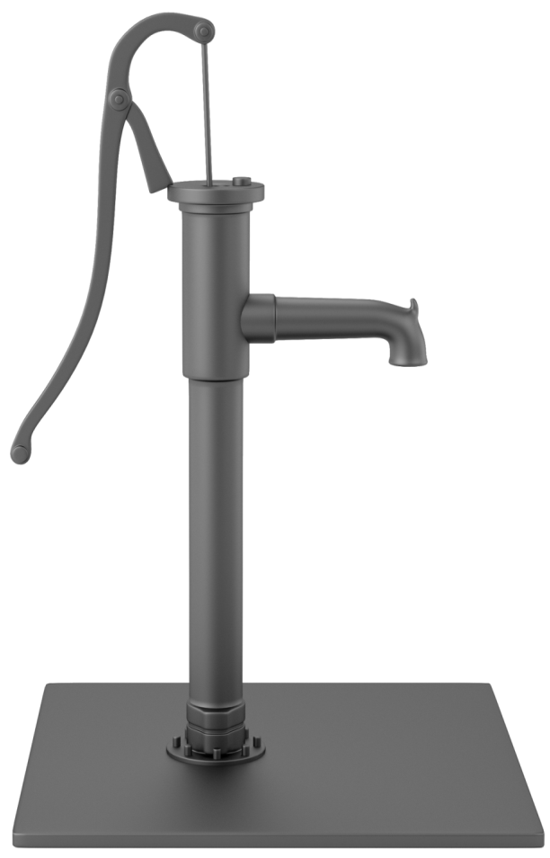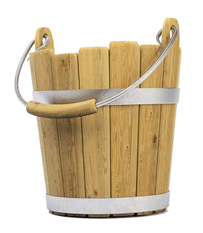

Resources:
- Heidenreich C, Lye P, Simpson D, Lourich M. The search for effective and efficient ambulatory teaching methods through the literature. Pediatrics. 2000;105(1);S231-237.
- Pettit J, Rosenbaum M. Strengthening Your Teaching Toolbox. MedEdPORTAL Publications; 2014. Available from: https://www.mededportal.org/publication/9873 http://dx.doi.org/10.15766/mep_2374-8265.9873.

Created by WISE FM: Douglas Bower, MD, David Deci, MD, Maureen Longeway, MD, & Deborah Simpson, PhD with graphic support from Sharon Sabourin. Published July 2015 as part of WISE FM (Wisconsin Institute of Scholars & Educators in Family Medicine); a statewide faculty development collaborative affiliated with:

